# SNAPSHOT OF VM AND RUN THE PREVIOUS TASKS

**STEP – 1:**

Create virtual machine.

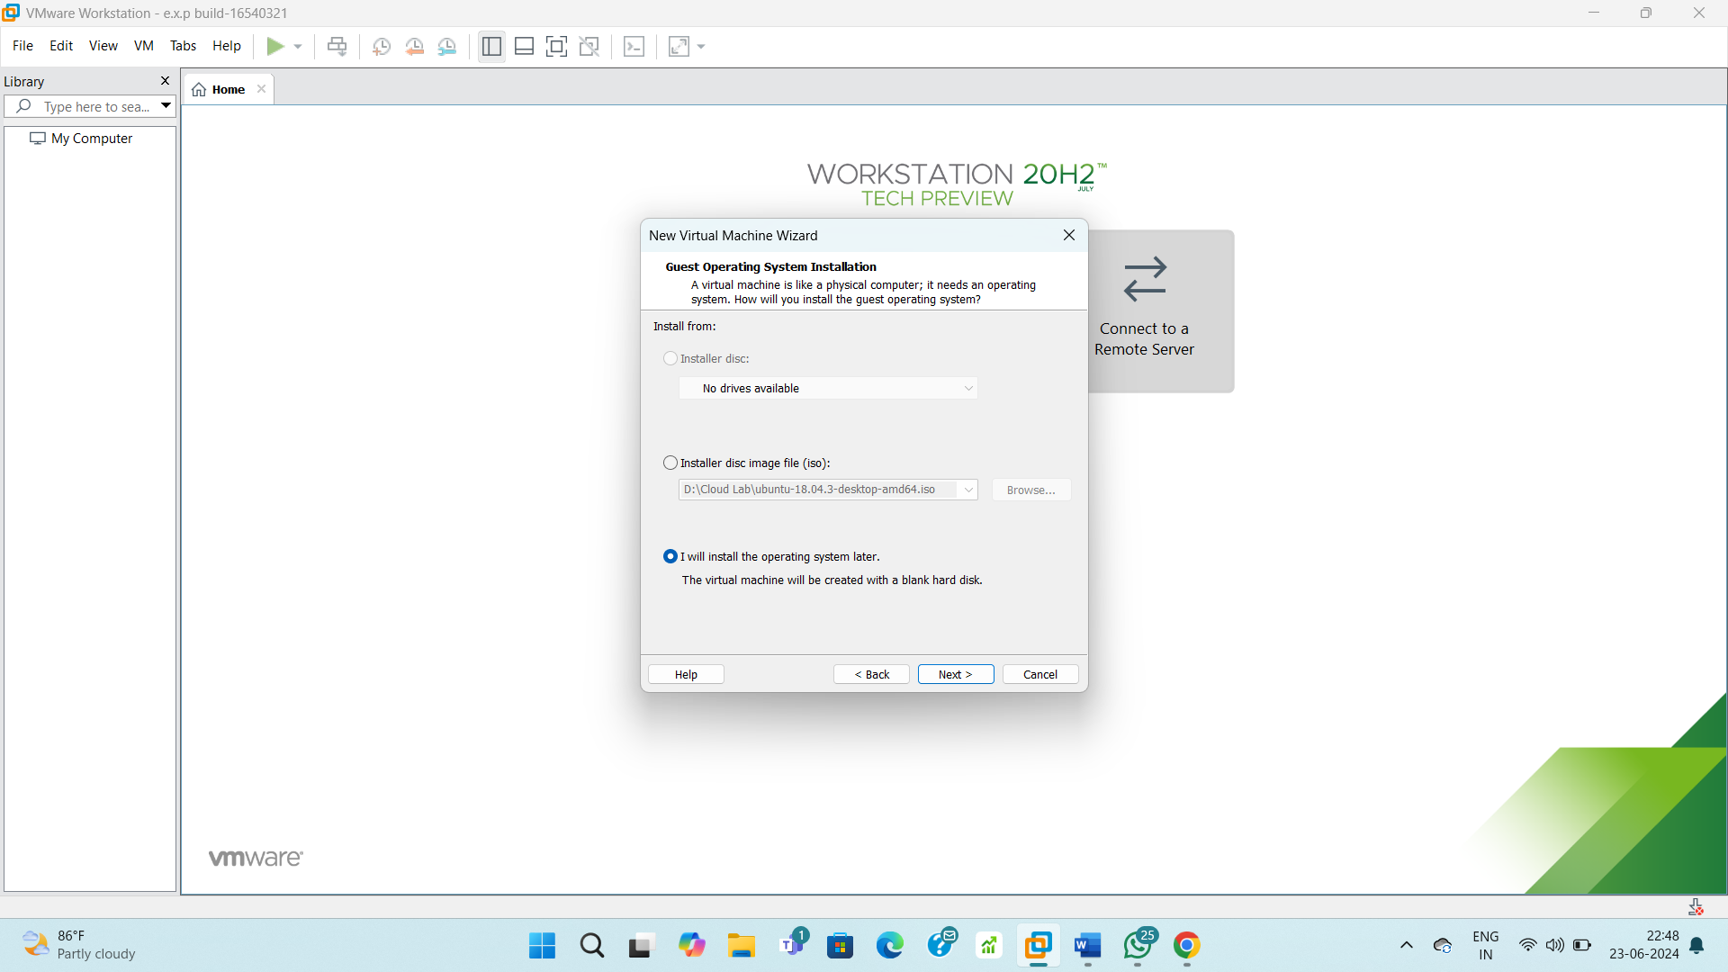

**STEP – 2:**

Use an OS.

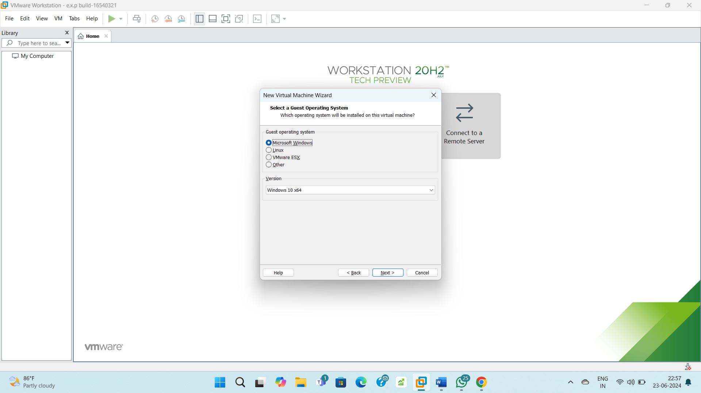

**STEP – 3:**

Allocate disk storage.

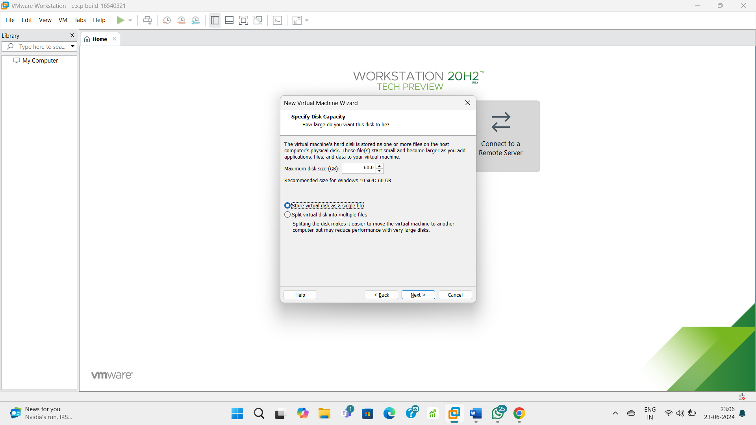

**STEP – 4:**

Create a snapshot of VM.

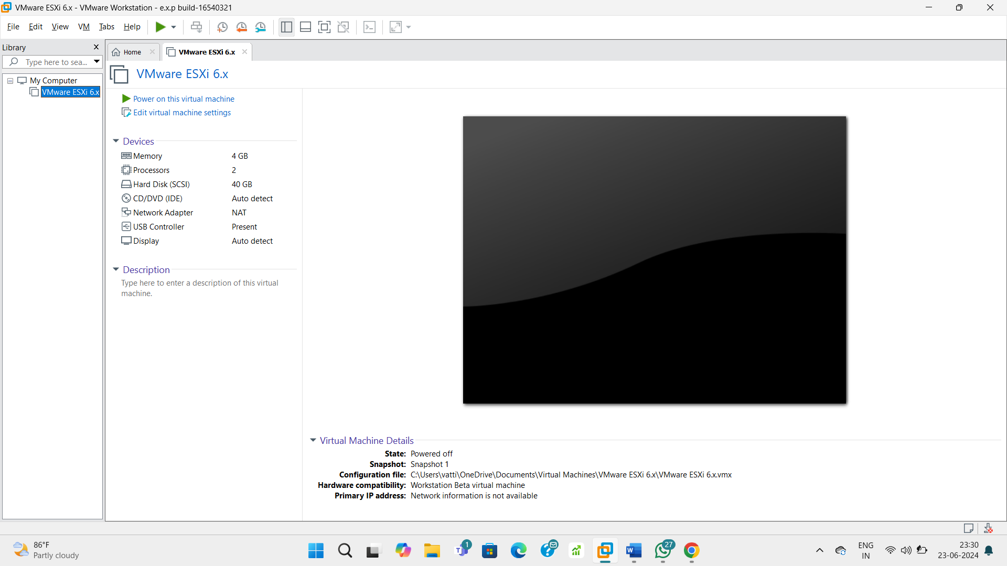

**STEP – 5:**

Go to snapshot manager.

